Statistical methods to study microbial communities

C.F.

24 février 2020

All three groups will be studied at the genus level, since it is the lowest shared amongst all of our three groups. DBZ, LB, LG and TL are referred as “soils”. DBZ1, DBZ2, DBZ3, … are referred as “samples”

# Dissimilarity analysis

## Heatmaps

By generating a heatmap based on algae community composition, it appears that dark LB soils are the most different when compared to the other soils. On the other hand, LG soils seem rather similar to other soils (lot of bright yellow and orange). TL algal communities do not seem to differ much between light and dark, while the same observation do not apply for the 3 other soils.

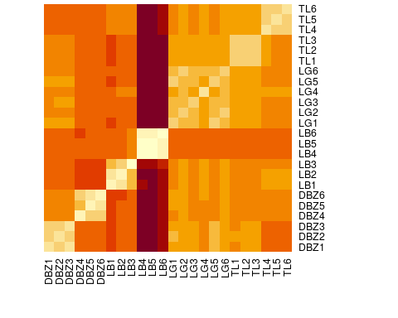  
Illustration 1: Algae genus heatmap

The same observations can be drawn from the bacteria communities heatmap. Altough it is interesting to notice that the light treatment do not affect LB bacterial communities as it affected its algal communities.

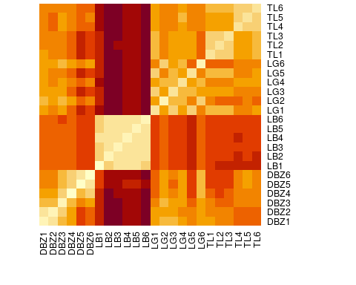  
Illustration 2: Bacteria genus heatmap

The fungal heatmap remains to be interpreted once data will be uptdated with no columns missing.

## Clustering trees

A quick look at the algae genus dendrogram confirms the previous observations. Dark LB soils are grouped apart from all the other soils. Most LG soils are placed at the full right of the tree which mean that, on the first hand, LG soils are very similar from each other, no matter the light treatment, and on the other hand, they are the less dissimilar soils from the other 3 soil location when compared to other soils. The last observation is that all soils except LG react to light treatment since they appear grouped by either light or dark conditions. This is expected since phototrophs heavily rely on light to thrive. In dark conditions, the algae community would hence be expected to change, possibly to become more facultative-heterotrophs oriented.

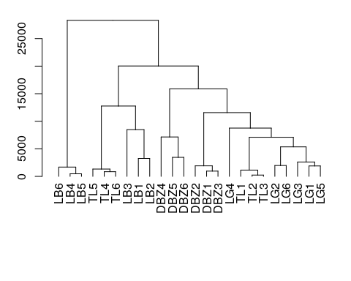  
Illustration 3: Algae genus dendrogram

However, things looks quite different when algaes are exchanged for bacteria. LB soils still appear as the most dissimilar of all soils, but they are not grouped by light treatment anymore. Nonetheless, DBZ and TL soils bacterial communities still show a reaction to light since they’re grouped by light treatment. Surprinsingly, LG soils, even if they do not show any specific pattern regarding light, seem to be splitted into two different branches, with the first branch being more similar to all TL soils than to the second LG branch. To understand that, we’ll need to look deeper into community composition. Anyway, it seems that bacteria communities show less reaction to light compared to algae communities, which makes sense since bacteria are heterotrophic organisms (cyanobacteria are not included in the bacteria group). 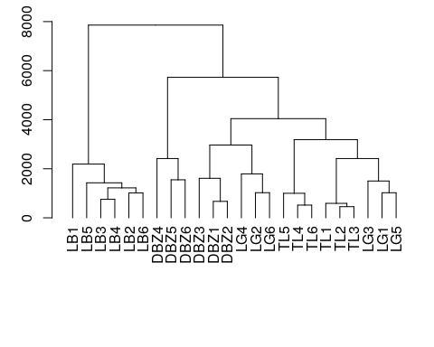

The fungal communities dendrogram remains to be interpreted once data will be updated with no missing columns.

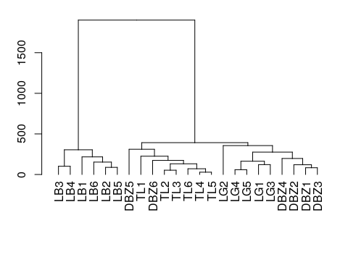

# Community barplots

## aakar already registered with pdfFonts().

## Abyssinica SIL already registered with pdfFonts().

## Ani already registered with pdfFonts().

## AnjaliOldLipi already registered with pdfFonts().

## Chandas already registered with pdfFonts().

## Chilanka already registered with pdfFonts().

## DejaVu Math TeX Gyre already registered with pdfFonts().

## DejaVu Sans already registered with pdfFonts().

## DejaVu Sans Light already registered with pdfFonts().

## DejaVu Sans Condensed already registered with pdfFonts().

## DejaVu Sans Mono already registered with pdfFonts().

## DejaVu Serif already registered with pdfFonts().

## DejaVu Serif Condensed already registered with pdfFonts().

## Droid Sans Fallback already registered with pdfFonts().

## Dyuthi already registered with pdfFonts().

## FreeMono already registered with pdfFonts().

## FreeSans already registered with pdfFonts().

## FreeSerif already registered with pdfFonts().

## Gargi already registered with pdfFonts().

## Garuda already registered with pdfFonts().

## Gubbi already registered with pdfFonts().

## Jamrul already registered with pdfFonts().

## KacstArt already registered with pdfFonts().

## KacstBook already registered with pdfFonts().

## KacstDecorative already registered with pdfFonts().

## KacstDigital already registered with pdfFonts().

## KacstFarsi already registered with pdfFonts().

## KacstLetter already registered with pdfFonts().

## KacstNaskh already registered with pdfFonts().

## KacstOffice already registered with pdfFonts().

## KacstOne already registered with pdfFonts().

## KacstPen already registered with pdfFonts().

## KacstPoster already registered with pdfFonts().

## KacstQurn already registered with pdfFonts().

## KacstScreen already registered with pdfFonts().

## KacstTitle already registered with pdfFonts().

## KacstTitleL already registered with pdfFonts().

## Kalapi already registered with pdfFonts().

## Kalimati already registered with pdfFonts().

## Karumbi already registered with pdfFonts().

## No regular (non-bold, non-italic) version of Keraleeyam. Skipping setup for this font.

## Khmer OS already registered with pdfFonts().

## Khmer OS System already registered with pdfFonts().

## More than one version of regular/bold/italic found for Kinnari. Skipping setup for this font.

## Laksaman already registered with pdfFonts().

## More than one version of regular/bold/italic found for Liberation Mono. Skipping setup for this font.

## More than one version of regular/bold/italic found for Liberation Sans. Skipping setup for this font.

## Liberation Sans Narrow already registered with pdfFonts().

## More than one version of regular/bold/italic found for Liberation Serif. Skipping setup for this font.

## Likhan already registered with pdfFonts().

## LKLUG already registered with pdfFonts().

## Lohit Assamese already registered with pdfFonts().

## Lohit Bengali already registered with pdfFonts().

## Lohit Devanagari already registered with pdfFonts().

## Lohit Gujarati already registered with pdfFonts().

## Lohit Gurmukhi already registered with pdfFonts().

## Lohit Kannada already registered with pdfFonts().

## Lohit Malayalam already registered with pdfFonts().

## Lohit Odia already registered with pdfFonts().

## Lohit Tamil already registered with pdfFonts().

## Lohit Tamil Classical already registered with pdfFonts().

## Lohit Telugu already registered with pdfFonts().

## Loma already registered with pdfFonts().

## Meera already registered with pdfFonts().

## Mitra Mono already registered with pdfFonts().

## mry_KacstQurn already registered with pdfFonts().

## Mukti Narrow already registered with pdfFonts().

## Nakula already registered with pdfFonts().

## Navilu already registered with pdfFonts().

## More than one version of regular/bold/italic found for Norasi. Skipping setup for this font.

## Noto Mono already registered with pdfFonts().

## OpenSymbol already registered with pdfFonts().

## Padauk already registered with pdfFonts().

## Padauk Book already registered with pdfFonts().

## More than one version of regular/bold/italic found for padmaa. Skipping setup for this font.

## No regular (non-bold, non-italic) version of padmaa-Bold.1.1. Skipping setup for this font.

## Pagul already registered with pdfFonts().

## Phetsarath OT already registered with pdfFonts().

## Pothana2000 already registered with pdfFonts().

## Purisa already registered with pdfFonts().

## Rachana already registered with pdfFonts().

## RaghuMalayalam already registered with pdfFonts().

## Rekha already registered with pdfFonts().

## Saab already registered with pdfFonts().

## Sahadeva already registered with pdfFonts().

## Samanata already registered with pdfFonts().

## Samyak Devanagari already registered with pdfFonts().

## Samyak Gujarati already registered with pdfFonts().

## Samyak Malayalam already registered with pdfFonts().

## Samyak Tamil already registered with pdfFonts().

## Sarai already registered with pdfFonts().

## Sawasdee already registered with pdfFonts().

## Suruma already registered with pdfFonts().

## Tibetan Machine Uni already registered with pdfFonts().

## TlwgMono already registered with pdfFonts().

## TlwgTypewriter already registered with pdfFonts().

## Tlwg Typist already registered with pdfFonts().

## Tlwg Typo already registered with pdfFonts().

## Ubuntu already registered with pdfFonts().

## Ubuntu Light already registered with pdfFonts().

## Ubuntu Condensed already registered with pdfFonts().

## Ubuntu Mono already registered with pdfFonts().

## More than one version of regular/bold/italic found for Umpush. Skipping setup for this font.

## No regular (non-bold, non-italic) version of Uroob. Skipping setup for this font.

## utkal already registered with pdfFonts().

## Vemana2000 already registered with pdfFonts().

## Waree already registered with pdfFonts().

## More than one version of regular/bold/italic found for Garamond. Skipping setup for this font.

## More than one version of regular/bold/italic found for Roboto Condensed. Skipping setup for this font.

